Mr.Jollyboy Music

A Yahoo / Google search for the term "Jollyboy" or "Mr.Jollyboy"

xxxxxxxxxxxxxxxxxxxx

British Library

http://catalogue.bl.uk/F/?func=file&file_name=login-bl-list - click on Search the Integrated Catalogue - then enter 'jollyboy' and click on Go

xxxxxxxxxxxxxxxxxxxx

System number - 005269339
Author - personal - Grimshaw, Emile.
Title - Mister Jollyboy.
Publisher/year - London : Clifford Essex Co., [1914]
Physical descr. - 1 score (3p) ; 35cm. + 2 parts.
General note - For two banjos and piano.
Subject - Banjos (2) with keyboard
Holdings (All) - Details
Shelfmark - h.3826.n.(19.) Request
ISBN - No price
Dewey class. no. - 785.28193 20
Other class. no. - TTNTQ bcmc

xxxxxxxxxxxxxxxxxxxx

System number - 005275638
Author - personal - Penso, Ralph.
Uniform title - [Mr. Jollyboy; arr. ]
Title - Mr. Jollyboy : two-step / arranged by H.M. Higgs.
Publisher/year - London : Chappell & Co., c1910.
Physical descr. - 5p. ; 36cm.
General note - For piano.
Pl. no. 24521.
Subject - Two-steps for piano solo
Added name - Higgs, Henry Marcellus.
Holdings (All) - Details
Shelfmark - h.3827.ff.(35.) Request
ISBN - No price
Plate number - 24521 Chappell & Co.
Dewey class. no. - 786.21887 20
Other class. no. - QPHVU bcmc

xxxxxxxxxxxxxxxxxxxx

System number - 005277118
Author - personal - Slaughter, Marjorie.
Title - Mr Jollyboy : dance intermezzo : piano.
Publisher/year - London : Frank Howard, c1913.
Physical descr. - 7p. ; 36cm.
General note - Pl. no. F.H. Ltd. 5021.
Subject - Dances for piano solo
Holdings (All) - Details
Shelfmark - h.3828.i.(6.) Request
ISBN - No price
Plate number - F.H. Ltd. 5021 Frank Howard
Dewey class. no. - 786.2188 20
Other class. no. - QPH bcmc

xxxxxxxxxxxxxxxxxxxx

System number - 004575477
Cataloguing level - Minimal record
Author - personal - Penso, Ralph.
Title - Mr. Jollyboy. Song, words by A. Wimperis, etc.
Publisher/year - London, etc : Chappell & Co, (1910.)
Physical descr. - fol.
Holdings (All) - Details
Shelfmark - H.1792.y.(14.) Request

xxxxxxxxxxxxxxxxxxxx

National Library - Australia

xxxxxxxxxxxxxxxxxxxx

http://catalogue.nla.gov.au/Record/4539768?lookfor=jollyboy&offset=1&max=1

Mr. Jollyboy [music] : song / words by Arthur Wimperis ; music by R. Penso
Music Bib ID 4539768
Format Music, Online - Google Books
Author Penso, R

Description London ; Melbourne : Chappell & Co., [c1910]
1 score (8 p.) ; 36 cm.
Notes For voice and piano.
Cover title.
Pl. no.: 24506.
"As sung by The Grotesques in their entertainment".
"Sung by Mr Fred Winn in The Gay Gordons".
Subjects Songs with piano. | Humorous songs - Scores.
Other Authors Wimperis, Arthur, 1874-1953
Music Publisher Number 24506

xxxxxxxxxxxxxxxxxxxx

SheetMusicWarehouse.co.uk

xxxxxxxxxxxxxxxxxxxx

http://www.sheetmusicwarehouse.co.uk/details.php?ref=28666

Category
20th Century Songs
Title
Mr Jollyboy, Two Step
Stock Reference Number
28666
Composer
Words and music - R Penso, H M Higgs
Publisher
Published By Chappell & Co., London,
Description
© 1910, Very Good condition
Price
£ 15

xxxxxxxxxxxxxxxxxxxx

http://www.sheetmusicwarehouse.co.uk/details.php?ref=27038

Category
Illustrated Music Covers
Title
Mr Jollyboy, as sung by "The Grotesques",
Stock Reference Number
27038
Composer
W&M. Arthur Wimperis, R Penso,
Publisher
Published By Chappell & Co. Ltd., London,
Description
© 1910, Fine condition
Price
£ 20

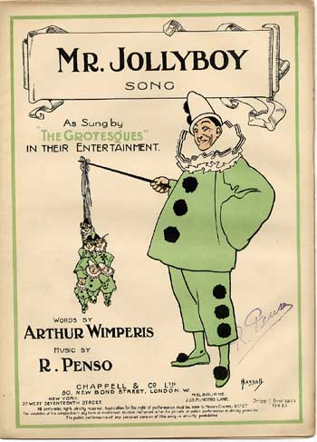

xxxxxxxxxxxxxxxxxxxx

http://www.sheetmusicwarehouse.co.uk/details.php?ref=31189

Category
20th Century Songs
Title
Chappell & Cos Annual Dance Album No158,
Stock Reference Number
31189
Composer
The Merry Widow, Sourire DAmour, The Arcadians, Jessamine, Mr Jollyboy, Catch Me, Under the PInes, Merry and Bright, The Espada,
Publisher
Chappell & Co. Ltd. London
Description
© 1907, Very Good condition
Price
£ 12

xxxxxxxxxxxxxxxxxxxx

Sibley Music

xxxxxxxxxxxxxxxxxxxx

http://www.sibley-music.co.uk/cd_recordings.htm

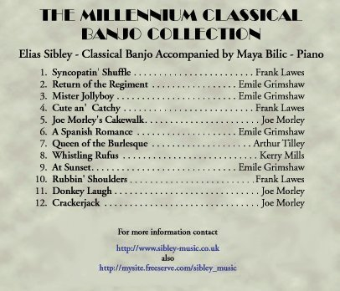

xxxxxxxxxxxxxxxxxxxx

New Criterion Banjo Orchestra - 2008

xxxxxxxxxxxxxxxxxxxx

http://www.classicbanjo.com/ncbo.php

Song List
Red Rover March || The Entertainer || The Grand Old Man || Jackstraws Polka || Skeleton Dance || Tickled To Death || A Banjo Oddity || Annie of the Vale || Ladbroke March || Mr. Jollyboy || Camilla || A Speedy and Tasteless Remedy || Dill Pickles || Georgia Grind || A Creole's Dream || Fun On The Wabash || Sailing, Sailing || Queen of the Ball || The Washington Post

Copyright 2008 Hal Allert. All rights reserved.

xxxxxxxxxxxxxxxxxxxx

